Define roles and rules in Power BI Desktop
You can define roles and rules within Power BI Desktop. When you publish to Power BI, it also publishes the role definitions.
To define security roles, follow these steps.
- Import data into your Power BI Desktop report or configure a Direct Query connection.
Note
You can't define roles within Power BI Desktop for Analysis Services live connections. You need to do that within the Analysis Services model.
- From the Modelling tab, select Manage Roles.
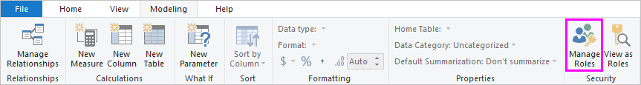
- From the Manage roles window, select Create.
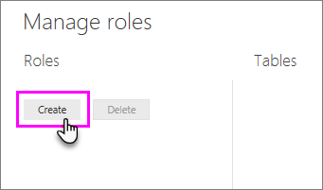
- Under Roles, provide a name for the role.
- Under Tables, select the table to which you want to apply a DAX rule.
- In the Table filter DAX expression box, enter the DAX expressions. This expression returns a value of true or false. For example: [Entity ID] = “Value”.

Note
You can use username() within this expression. Be aware that username() has the format of DOMAIN\username within Power BI Desktop. Within the Power BI service and Power BI Report Server, it's in the format of the user's User Principal Name (UPN). Alternatively, you can use userprincipalname(), which always returns the user in the format of their user principal name, username@contoso.com.
- After you've created the DAX expression, select the checkmark above the expression box to validate the expression.
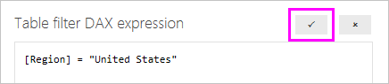
Note
In this expression box, you use commas to separate DAX function arguments even if you're using a locale that normally uses semicolon separators (e.g. French or German).
- Select Save.

Validate the roles within Power BI Desktop
After you've created your roles, test the results of the roles within Power BI Desktop.
- From the Modeling tab, select View as Roles.
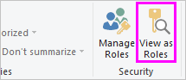
The View as roles window appears, where you see the roles you've created.
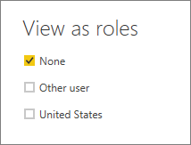
- Select a role you created, and then select OK to apply that role.
The report renders the data relevant for that role.
- You can also select Other user and supply a given user.
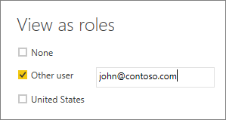
It's best to supply the User Principal Name (UPN) as that's what the Power BI service and Power BI Report Server use.
Within Power BI Desktop, Other user displays different results only if you're using dynamic security based on your DAX expressions.
- Select OK.
- Publish the report to Power B

Manage security on your model
To manage security on your data model, you will want to do the following.
- Select the ellipse (…) for a dataset.
- Select Security.
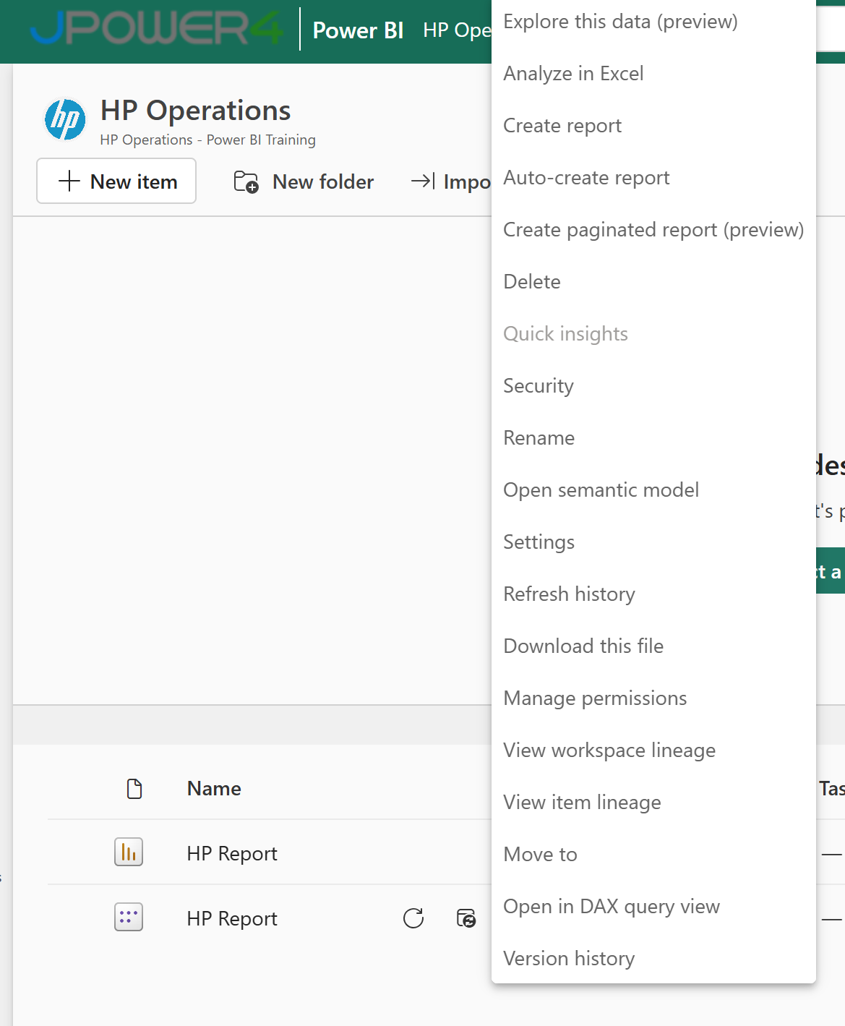
This will take you to the RLS page for you to add members to a role you created in Power BI Desktop. Only the owners of the dataset will see Security available. If the dataset is in a Group, only Administrators of the group will see the security option.
You can only create or modify roles within Power BI Desktop.

Working with members

Add members
You can add a member to the role by typing in the email address, or name, of the user, security group or distribution list you want to add. You cannot add Groups created within Power BI. You can add members external to your organization.
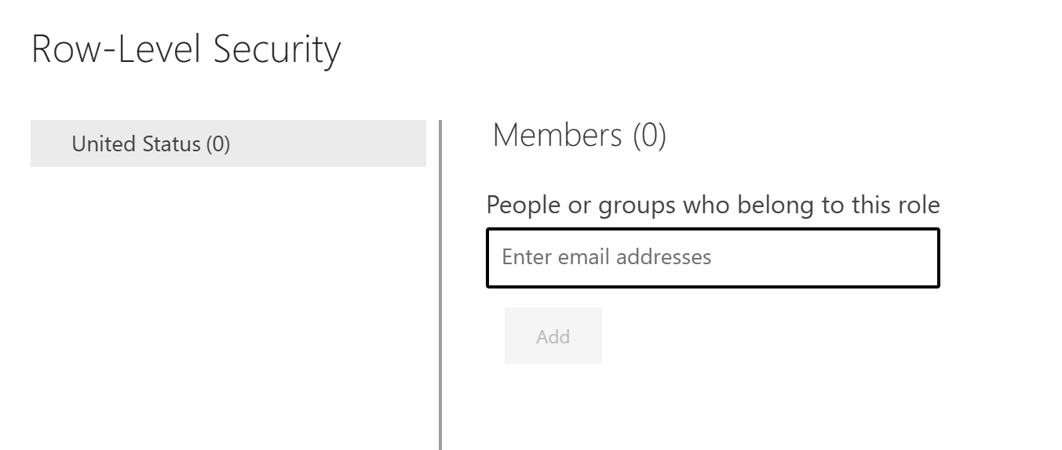
You can also see how many members are part of the role by the number in parenthesis next to the role name, or next to Members.
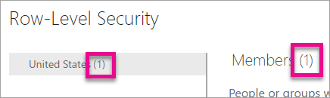

Remove members
You can remove members by selecting the X next to their name.
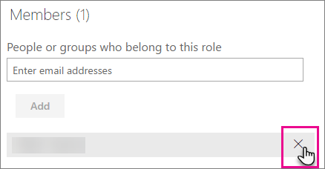

Validating the role within the Power BI service
You can validate that the role you defined is working correctly by testing the role.
- Select More options (...) next to the role.
- Select Test data as role
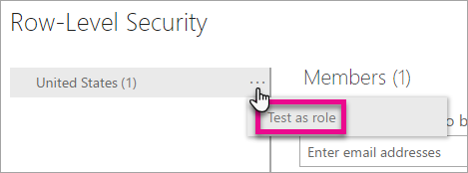
You will then see reports that are available for this role. Dashboards are not presented in this view. In the blue bar above, you will see what is being applied.
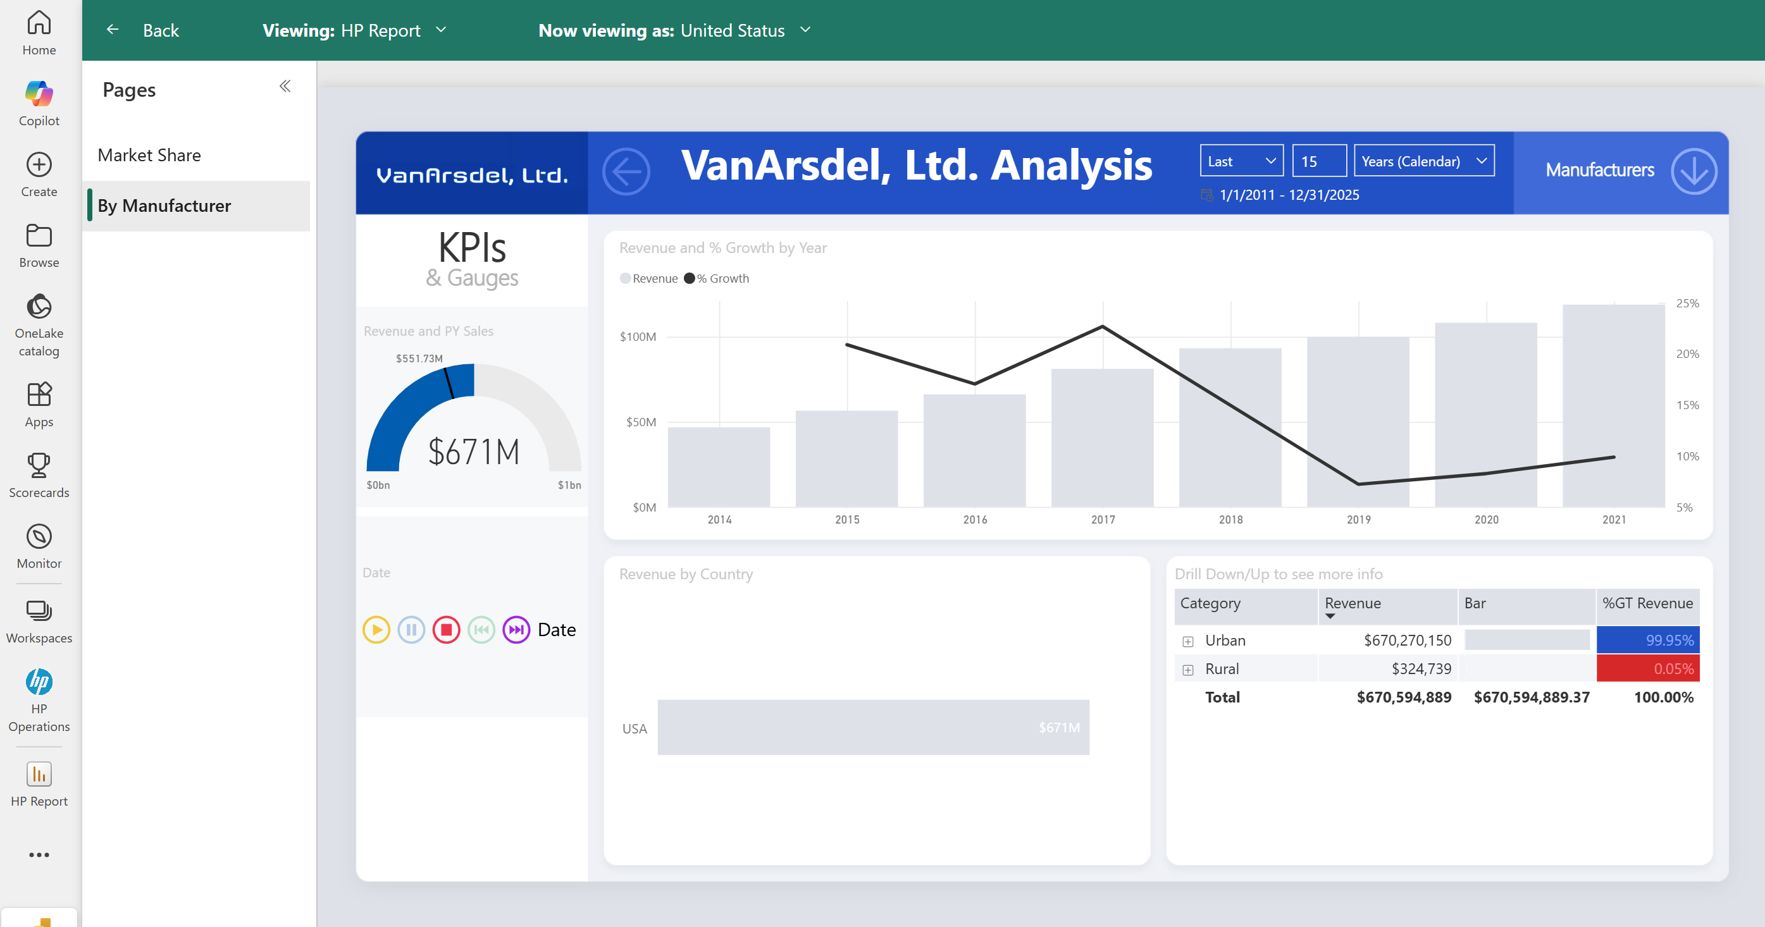
You can test other roles, or combination of roles, by selecting Now viewing as.
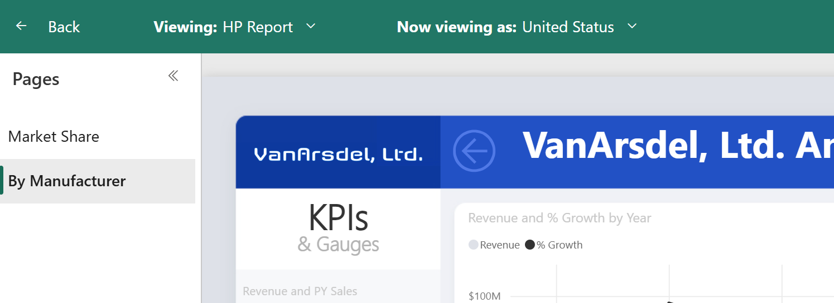
You can choose to view data as a specific person, or you can select a combination of available roles to validate they are working.
To return to normal viewing, select Back to Row-Level Security.

